**Selection of a Local Anesthetic**

Local anesthetics as other medicines, undergone extensive researches to reach to the most beneficial agents with lower rate of complications and side effects.

Some of the Local anesthetics that was previously used. Currently the most used LA are:

1. Articaine
2. Bupivacaine
3. Lidocaine
4. Mepivacaine
5. Prilocaine.

Duration

The time LA stays working depends on many factors beside the difference induration between hard tissue (Pulp) and soft Tissue. LA is longer for soft than hard tissue.

These factors include but are not limited to:

1. individual response to the drug (the normal distribution curve or “bell-shaped” curve)

2. accuracy in deposition of the local anesthetic

3. status of tissues at the site of drug deposition (vascularity, pH)

4. anatomic variation 5. type of injection administered (supraperiosteal [“infiltration”] or nerve block).

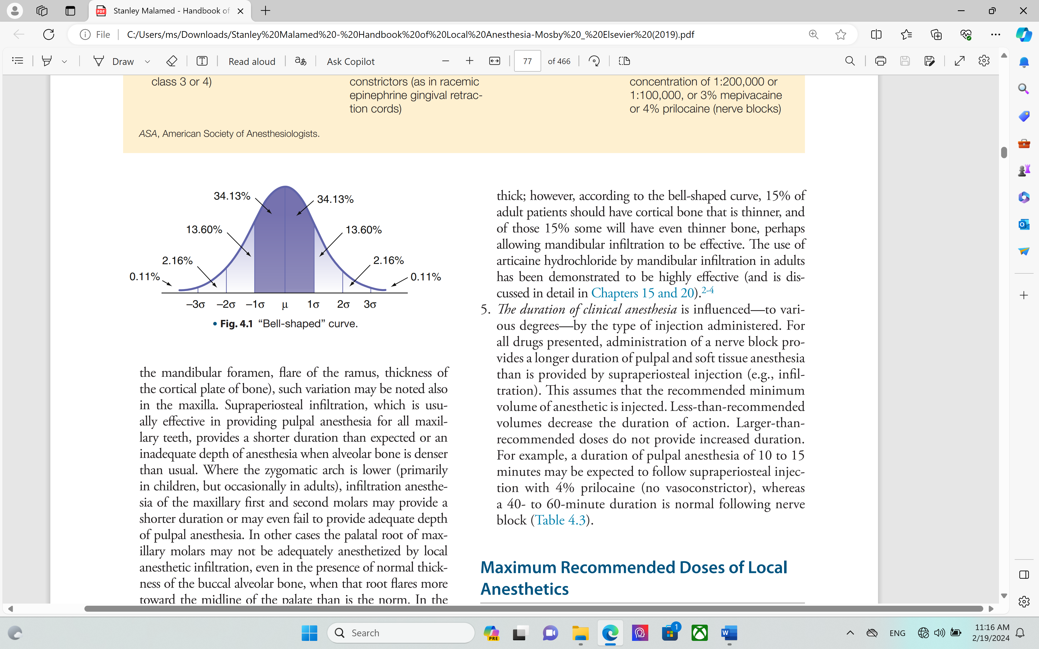

* Local anesthesia is a medicine and so its administration requires knowledge of the amount of that can be given to avoid toxic doses. It’s the operator responsibility when he faces a situation needs a high amount of anesthesia. Below are the common LA with their doses

|  |  |  |  |  |  |  |  |  |  |  |  |  |
| --- | --- | --- | --- | --- | --- | --- | --- | --- | --- | --- | --- | --- |
| LA | | | Dosage | | Group | PG | | | Lactation | | | MRD |
| Lidocaine | | | With VC 7 | | Amide | B | | | Safe | | | 500 |
| With out VC 4.5 | |  |
| Articaine | | | With VC 7 mg | | Amide | C | | | Unknown | | |  |
| Mepivacaine | | | With VC 6.6 | | Amide | C | | | Unknown | | | 400 |
| With out VC 6.6 | | 400 |
| Bupivacaine | | | With VC 2.0mg | | Amide | C | | | Unknown | | | 200 |
| Prilocaine | | | With VC 8mg | | Amide | B | | | Unknown | | | 600 |
| With out VC 8mg | | 600 |
| * MRD: Maximum recommended dosage | | | | | | | * PG: pregnancy category | | | | * LA: local anesthesia | |
| **LA** | **Onset** | | **Duration on ST** | | | | **Duration on HD** | | **EDC** | | |
| **Lidocaine** | 3-5 | | 180–300 | | | | 60 | | 2% | | |
| **Mepivacaine** | 3-5 | | Without VC:120–180  with VC :180–300 | | | | 20: infiltration  40: nerve block  60: with vasoconstrictor | | 3% without VC  2% with VC (Levonordefrin) | | |
| **Prilocaine** | 3-5 | | Without VC 90–120: infiltration 120–240: nerve bloc  With VC 180–480 | | | | Without VC 10–15: infiltration 40–60: nerve block  With VC 60–90 | | 4% | | |
| **Articaine** | 1 to 9 | | With VC 180–360 | | | | With VC 60–75 | | 4% | | |
| **Bupivacaine** | 6 to 10 | | With VC 240–540 (≤720) | | | | With VC 90–180 (≤360) | | 0.5 | | |
| HD hard tissue…..ST:soft tissue…..EDC: effective dental concentration | | | | | | | | | | | |

**Topical anesthetics**

The injection with local anesthetics is a major obstacle for dental visits, fear from needle could subject person to vasovagal attack and compromise treatment. Topically applied anesthetics could reduce the pain associated with needle penetration. Agents that could be used for this purpose:

|  |  |
| --- | --- |
| * Benzo caine: Ester group | * Tetracaine |
| * Cocaine: Ester group | * EMLA |

* EMLA (Eutectic Mixture of Local Anesthetics EMLA cream (composed of 2.5% lidocaine and 2.5% prilocaine) is an emulsion in which the oil phase is a eutectic mixture of lidocaine and prilocaine.

**Calculation of local anesthesia**

The proper understanding of the number of LA that can be given need detailed information about the percentages of each LA in the carpule, volume of the carpule, maximum dose required for each LA and patients weight.

* Example of this, Lady 50 kg weighted how many carpules of 2% lidocaine can be given?
* Most carpules are 1.8 ml in volume.
* 2% lidocaine means 2000mg per 100 ml and so 20mg per 1ml
* 20mg * 1.8 ml = 36mg per one carpule
* Accepted dose of lidocaine is 7mg per Kg and so in 50kg lady 7 * 50= 350 mg maximum
* Numbers of carpules are 350 / 36≃ 10 carpules.
* In certain situations, operator is imposed to give different agents of LA, like starting with mepivacaine but the patient still feel pain and convert to another agent. In such circumstances always depend on the agent with the lower dosage in calculation of total dose and carpules to be given. Keep in mind the calculation is the same as previously mentioned.
* Factors in Selection of a Local Anesthetic for a Patient

1. Length of time pain control is necessary

2. Potential need for posttreatment pain control

3. Possibility of self-mutilation in the postoperative period

4. Requirement for hemostasis

5. Presence of any contraindications (absolute or relative) to the local anesthetic solution selected for administration